**Ghibli Dashboard User Manual**

# **Table of Contents**

Table of Contents 1

Introduction 1

Overview 2

Popularity 3

Finance 3

In-Depth Report 4

# **Introduction**

**The purpose of the dashboard is to visualize Studio Ghibli's work results across different dimensions**, to enable analysis on aspects such as film popularity and their financial performance.

The dashboard structure consists of **four** pages:

* A general introductory overview ("*Overview*")
* A page dedicated to the popularity dimension and audience response ("*Popularity*")
* A page focused on the studio's financial aspect and each film ("*Finance*")
* ****A section designed to allow an in-depth analysis of each film in detail according to the highlighted metrics using drill through within the dashboard ("*In-Depth*").

# **preencoded.pngOverview**

**The "*Overview*" page is designed to function according to a regional filter** ("*Region*") that localizes data according to Japan (domestic data), the international market (Western data) and a global overview (default selection). **The visual objects and KPIs highlighted in the report change based on the highlighted region**, in order to provide a localized overview to highlight any differences or emphasize similarities.  
The year slicer ("*Year*"), combinable with the regional selector, contains the information shown in a specific range of years.

1: The box shows the poster of the film that enjoys the average review score in the reference region. It can therefore be considered the "best film" for a given region.

2: The KPI Cards show the number of films ("*Movies*") released, the total box office revenue achieved ("*Box Office Revenue*") and the average rating score of all films ("*Average Review Score*"). The data on the cards changes based on the selected region and the highlighted year range.

3: The chart shows the trend of Studio Ghibli's total box office revenue over the years, combining those of any films released in the same year.

4: The bars show the response in terms of average review scores of films based on the director who made them. The directors' names can act as a filter for the page, highlighting any observations that want to be derived based on the director.

# **preencoded.pngpreencoded.pngPopularity**

**The *Popularity* page highlights the response of films according to three audience segments**:  
specialized film critics ("*Critic*"), Japanese fans of the anime world ("*Japan*") and Western fans ("*West*"). It is possible to alter the number of films shown in the top (Top 1, Top 3, Top 5 and Top 10) using the selector on the right.

1: The rankings indicate the best films and the average score attributed by these three segments.

****2: The bar chart shows score comparisons for each film according to the three segments.  
It can be used to highlight the greater success of a film for one segment rather than another, or the tendency of a specific segment to attribute more or less strict ratings.

# **preencoded.pngpreencoded.pngFinance**

**The *Finance* page shows a financial overview of the studio and the films produced.** It divides the box office totalized in the film's launch period ("*Opening*") from those to date (*"YTD"*), which considers any re-broadcasts and redistributions.

1: The scatter plot highlights the relationship between the film's budget and the box office achieved in the launch period. The size of the spheres indicates the return on investment that these have returned based on the budget. Both of these metrics can be filtered through the integrated slicers.

2: The donut chart highlights the total box office divided by film genre.

3: The pie chart highlights the box office attributable to each director.

4: The bar chart represents the differences between the launch period box office and the total box office to date. It therefore highlights how some films have gained success over time, rather than just in the initial period.



# **preencoded.pngpreencoded.pngIn-Depth Report**

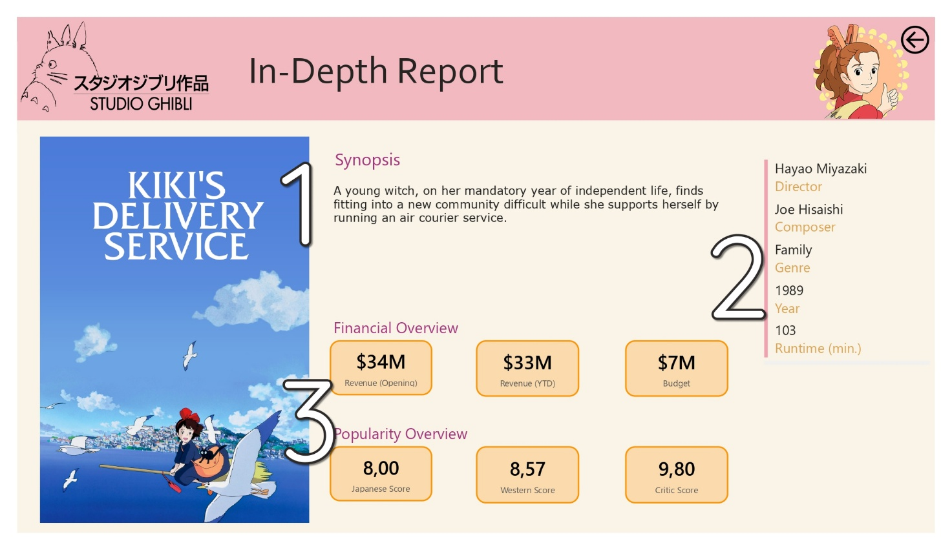

**The *In-Depth* page shows a detailed overview of each film**. To be used if you want to make observations relating to a specific product. **It is possible to select the film through drill through across the other visual objects on the other dashboard pages**; every time you select a title, in fact, it is possible to perform the in-depth analysis by arriving directly on this page.

1: The main block features the film poster accompanied by a brief synopsis.

2: The side table shows some general details such as the film's director, the person who curated the music, the genre, the release year and the duration.

3: The KPI Cards offer an immediate overview of financial dimensions ("*Financial Overview*") and popularity ("*Popularity Overview*").  
The first group highlights the box office earned by the film in its launch period, those relating to today and the budget used to make it. The second shows the film's average score compared to the three segments used in the *Popularity* page: Japanese animation fans, Western animation fans and specialized film critics.

